Gods’ Calling, Your Life
Sr. Youth Gathering
2025 Schedule

Friday
7:00-9:00 Registration/Check-in
8:30-10:00 Mass Event #1
10:00-10:30 Free Time
10:00-10:30 Counselor Orientation – Iowa B
10:30 In Room End of Day Reflections
11:30 Lights Out

Saturday
8:00-8:45 Breakfast
8:55-9:25 Bible Study #1
9:30-10:30 Mass Event #2
10:40-11:30 Sectional 1
11:40-12:30 Sectional 2
12:30-1:30 Lunch
1:40-2:35 Sectional 3
2:45-3:35 Servant Sectional
3:45-4:20 Bible Study #2
4:20-4:40 Free Time
4:40-6:00 Mass Event #3
6:00-7:00 Dinner
7:00-10:00 Nightlife
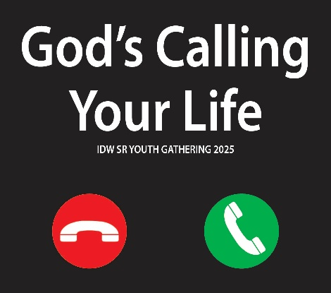
10:00-10:30 In Room Reflections
11:30 Lights Out
Sunday
8:00-8:45 Breakfast
9:00-10:30 Worship
10:30 Closing

