More pastor sightings! Quite the second half of August.
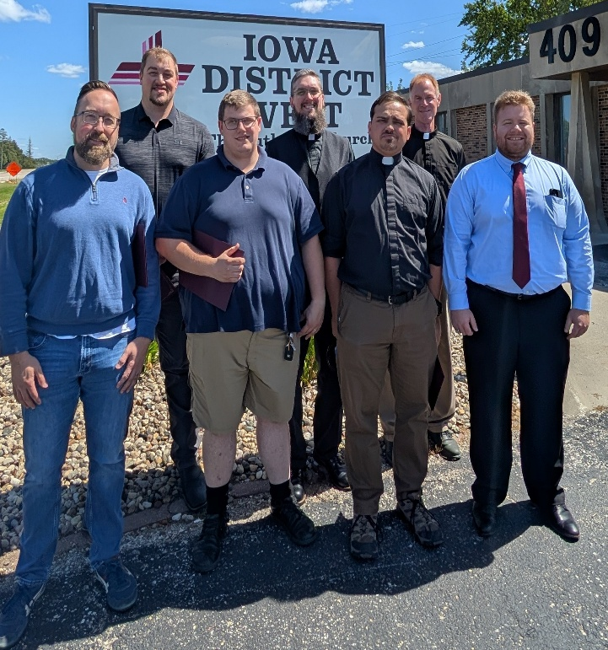
A whole bunch of circuit visitors graced the district office for our first meeting together. What did we discuss? Synod convention delegate elections, various circuit events and celebrations, congregational visitations, communion frequency statistics.
A couple days later our Storm Lake circuit pastors celebrated my leaving the circuit with lots of food and a bags game. Good news: Susan (Mrs Bradley) Ketcham and I dominated the competition.
Then the following Sunday what a glorious Divine Service with Joel Newton at St Paul’s, Ankeny, along with the afternoon installation of Rev Dave Kottlowski, an old friend. The next day was IDW golf. Nine pastors and three pastors’ sons cared for each other as God gave us beautiful weather. Thanks to Neil Wehmas for arranging and hosting. The very next day our new pastors and vicars met in Fort Dodge (see picture at right). What did we talk about? District and synod, closed communion and Lord’s Supper frequency, officiating weddings and confirmation instruction and district events, Acts 19-20 and “keeping watch over yourselves and all the flock of which the Holy Spirit has made you overseers.”

August closed out first thing in the morning at Holy Cross, Carlisle with Rev Kevin Johnson’s faithful preaching, robust congregational singing, and quite a discussion during Bible class concerning routes to the pastoral ministry. Then it was over to Peace, Des Moines in the afternoon for Michael Barnes’ retirement. Jeff Kuening’s sermon honored Michael, one of God’s faithful servants, while also encouraging fellow pastors and God’s dear sons and daughters in the congregation.

September opened with two days of orientation and then five additional days for me at Council of Presidents meetings in St Louis. What did we talk about? 2 Timothy 4, AC XIII, visitations, roster maintenance, President Matt Harrison reporting on Lutheranism around the world and other opportunities, LCEF presentations, seminary presidents discussing routes to the pastoral ministry, Concordia Texas update, Lutheran Bible Translators working in 133 countries, who is coming/leaving the church and why, CADDS and other
congregational resources, 548 calling congregations, 785 congregations being served part time, and lots more.
After one of our chapel services at our International Center, LCMS President Harrison and CPH President Schulz presented each of us new district presidents with our TOOLS: A new Bible; a new Book of Concord; and our synod Bylaws.
When I returned, it was very refreshing to see the faces of our conference planning committee on the zoom screen. All is ready as we look forward to Dr Stephenson presenting “The Lord’s Supper” to us. Next, September 14th in Ida Grove. Rev Neil Wehmas preached from the theme “Holy Cross Day,” speaking of Jesus’ gifts from His cross alongside the parable of the Good Samaritan. Speaking of gifts from the cross, Rev. Wehmas noted their recent decision to celebrate our Lord’s Supper each weekend, alternating between Saturday and Sunday services. His hope is to one day offer our Lord’s Supper at each Divine Service. More of our congregations are returning to Christendom’s historic practice of celebrating the Lord’s Supper among the Lord’s people each Lord’s day. More on this hopefully in our November Messenger. My visit to Ida Grove was especially heartwarming as my oldest grandchild, 14-year-old Chloe, served as guest organist for Divine Service. After Divine Service one of the members said to her, “You blew the cobwebs out of the organ.”

Jesus, Lord of His Church, gathers sinner-saints together into congregations because He loves us.
Jesus, Lord of His Church, sets pastors down into their midst to bring them gifts God knows we need.

As angels sing,

Pastor Paul Egger
President, Iowa District West

