Iowa West pastors out and about! Bringing Jesus to people everywhere. Thanks be to God!

Since we left off in mid-September, I’ve eye-witnessed many of our pastors caring for many of God’s dear sons and daughters...
Pastors Kroonblawd and Ketcham and I met with the St Peter, Newell congregation to discuss future opportunities. Pastor Don Meyer visited Jon Riggert with me at the Estherville hospital, then met with Trinity, Cherokee elders, and a few days later the congregation. Mark Mattes, an AALC pastor spent a morning with me at the District Office, to discuss him offering to help with pulpit supply in and around the Des Moines area. We are currently in pulpit and altar fellowship with the AALC.

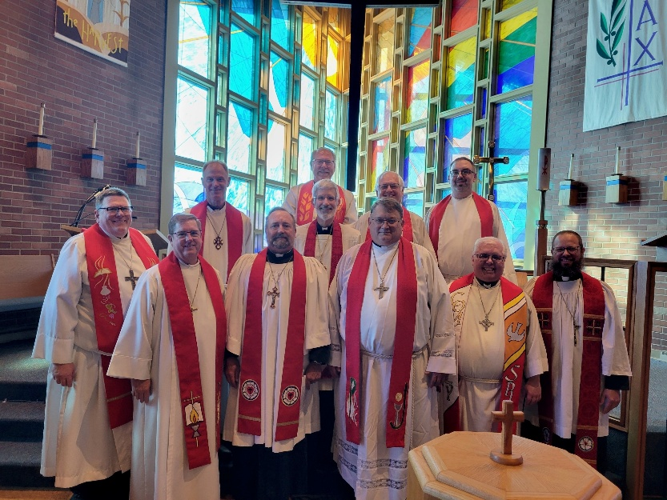
On September 21 I traveled to Immanuel, Rowan (Rev. Mark Eichler) as they celebrated their 50th anniversary. A wonderful congregation in the country, and their first pastor from 50 years ago returned, alongside other pastors. Their theme: Jesus really, really, really loves us! Then on to Ft Dodge as our conference planning committee took our conference speaker Dr. Stephenson and his wife Bonnie out for supper. Later that evening, I ran into Pastor Dennis Martens at the Ministry Center (old orphanage) and together we solved all the world’s problems. You’re welcome. Monday and Tuesday God gathered our district pastors together for our conference. Many thoughtful and fruitful discussions of God’s work among us. Holy Communion was our topic. Rev Gus George brought me a delicious sack of candy. Very nice! At his request I shared half with Jill at the district office. The next night, Rev Meyer and I were back at Trinity, Cherokee. Thursday, a prospective seminary student visited, and Rhonda Mohr invited me to share an opening devotion at our annual principal’s meeting.

Sunday September 28 brought me to Immanuel, Guthrie Center, in the morning. Rev. Bob Riggert preached and led Divine Service, followed by a pre-call meeting. Then on to Peace, Des Moines, to install Rev Matthew Tooman. He went to college with my little brother, Tom. Pastor Tooman was born and raised at Peace alongside Rev. Ed Durand. During the sermon Ed accused me of sitting in HIS pew. The following Tuesday, what a great confessions study at Grace, Storm Lake. A bunch of pastors wading into Smalcald.

As I write this, we’re halfway through October, my second favorite month of the year. I’ve seen a bunch of you on Zoom calls: circuit visitors, conference planning committee, district staff meeting zoom-ins and others.

Rev Max Phillips (he wears so many vital hats!) invited me to his office to discuss Lutheran Family Service and other godly endeavors. Then another district staff meeting. Rev Jerry Raether dropped by. So did Rev Paul Chuol, currently serving the Sudanese in Sioux City and Storm Lake. Rev Keith Haney sat with us to bring helpful counsel. Wednesday October 8, a congregational visit at Christ the King, Spencer, with Pastor Chris Nitzel to discuss Jesus’ work among them past, present and future. Lots of phone calls and emails and texts. But I especially appreciate seeing our IDW pastors out and about! Bringing Jesus to people everywhere. Thanks be to God!

Pastor Paul Egger

