February 20, 2020

Dear Friends in Christ,

I thank you and your congregation for supporting the mission of Iowa District West (IDW); we are honored by your generosity. We are blessed to be in strong partnership with our national church body, The Lutheran Church—Missouri Synod. Nearly 50% of congregational unrestricted receipts we receive are forwarded to St. Louis, Missouri in support of our ministry together across the country - and beyond! Gifts like yours, make a large impact in the work our Church is doing in Iowa and throughout the world.

The Apostle Paul reminds us in Colossians 3:14, “And over all these virtues put on love, which binds them all together in perfect unity.” We are joined together in Christ’s love. Without congregations like yours joining together with over 165 congregations throughout western Iowa, we could never do what we are called to do. We are stronger together!

One example is through your Hispanic missionary, Rev. Lincon Guerra. With your financial support, this ministry has included English classes, citizenship classes, VBS programs, Bible studies, worship, quilting, and special festivals. Our hope is that as God continues to work through missionaries like Pastor Guerra, all our neighbors will feel welcome in any IDW congregation. The love of Christ binds us together.

Thank you again for your personal and congregational generosity.

Always in Grace,
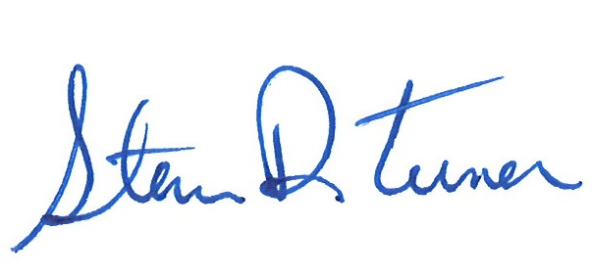

Pres. Steve Turner & staff of Iowa District West

