BUSINESS MANAGER NEWS

Iowa District West Congregations’ Mission Receipts

3

Month Ending July 2026
Anticipated Amount | $110,000
Actual Receipts | $111,433
Year-to-Date Receipts
Anticipated Amount | $660,000
Actual Receipts | $700,970
Over (under) anticipated amount | $40,970
Use of Mission Receipts
Remitted to Synod (45%) | $264,000
Balance for District programs & ministries | $436,970
Total Receipts | $700,970
Mission Receipts Compared with Last Year
Month ending July 2026 | $700,970
Month ending July 2025 | $690,239
Over (under) last year | $ 10,731



Partners in the Gospel - Monthly Mission Moment
Did you know that your congregational mission dollars support the District budget in a variety of missions, programs, and services including $60,000 for gift planning ministry in the stewardship budget? Leon Schoenfeld started with the LCMS Foundation this spring and is doing a great job helping families in Iowa District West prepare estate plans that provide for their loved ones and support their favorite LCMS ministries. According to Thrivent magazine, Summer 2026 issue, we are in the midst of the greatest wealth transfer in American history: $124 trillion will be passed on through 2048.
For more gift planning information, go to www.idwlcms.org/christian-estate-planning.php.

If you would like Leon to help you or your congregation at no cost or obligation, email leon.schoenfeld@lfnd.org or call 712.830.7481.


Stewardship Spark - by Ron Chewning, President of Stewardship Advisors, which provides year-round stewardship education resources for LCMS churches (248.644.6150 - stewardshipadv@aol.com)


STEWARDSHIP IS THE FREE AND
LOVING RESPONSE TO THE GRACE
OF GOD IN OUR LIVES.

“And God is able to make all grace abound
to you, so that having all sufficiency in all
things at all times, you may abound in every
good work” (2 Corinthians 9:8).

Congregational Quarterly Financial Report

Included in The Messenger is the report of congregational support for the first six months of the District’s fiscal period (February 1–July 31). Please review your church’s mission pledge to ensure your budget receipts are current. This report reflects only District/Synod receipts and does not include restricted missionary support or other program income. Your mission dollars enable us to be “On a Mission to Support Christ’s Mission.”
Thank you for your continued support!


Compensation & Benefit Recommendations

The Board of Directors approved the suggested compensation recommendations for 2027. To view the salary schedule, click here.

Another option to consider is the LCMS compensation tool used by congregations around the Synod to help determine fair and appropriate compensation for your workers. Click here for the direct link.

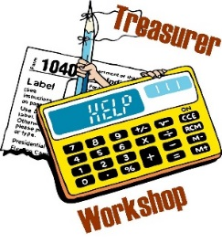
Church & Clergy Finance/Treasurer’s Workshop

Mark your calendar to attend the fall workshop on Saturday, November 7, from 9:00 a.m. to 1:00 p.m. at Our Saviour Lutheran Church in Denison. Pastors and any individuals within the church who have financial responsibilities are encouraged to attend.
Our guest speaker will be Bob Joy, CPA, who has been presenting for nearly 30 years and brings a wealth of knowledge and expertise to this workshop.
If you have any questions, please contact Roger at 515-576-7666 or Roger@IowaDistrictWest.org.


Secretarial/Administrative Assistants Fall Conference
There is still time to register for the District Administrative Assistants Conference on Tuesday, September 29, at St. Paul in Fort Dodge. The registration fee is only $45 when preregistered and paid before September 8. We are pleased to welcome back our outstanding speaker, Shannon Zetterlund, who will lead uplifting, encouraging, and educational sessions throughout the day. The conference brochure is available on the District Administrative News page. If you have any questions, please contact Roger Curtis or Michelle Hammersland.

October is Clergy & Church Worker Appreciation Month

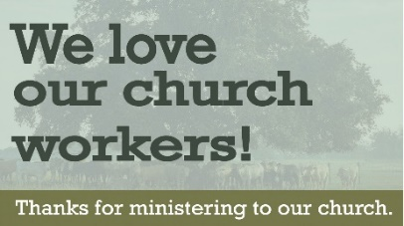
Church Worker Appreciation Month is a special time when congregations honor their pastor and church workers and their family for their hard work and sacrificial dedication. You might consider a special service of affirmation, a potluck event, or planting a tree in their honor. The sky’s the limit! It is usually scheduled in October but can be held at any time that is convenient for the church. Brainstorm ideas now so you can celebrate later this fall. For additional ideas, download details from Focus on the Family’s Clergy Appreciation Month Planning Guide or www.parsonage.org/cam and plan something for all church workers. Synod also has a good article online for ideas and resources. What can you do to support your pastor and church workers?

How Churches Can Prevent AI-Powered Fraud

Artificial intelligence (AI) is reshaping ministry operations, but it is also creating new risks for churches. Today’s scams are no longer easy to spot. AI-generated emails, voice messages, invoices and fake receipts can appear legitimate enough to fool even experienced church staff members.
Because of this, churches should strengthen financial controls, improve verification practices, and require stronger online security measures before fraud occurs. Congregations that rely heavily on trust, quick approvals, and informal communication processes are increasingly vulnerable to AI-driven scams targeting finances, payroll and sensitive ministry data. More information is available on the Church Law & Tax website.

